

Triangle
Environmental, Inc.

TriTester

Model: TVLM-001

Phase II Vapor Recovery

Vapor/Liquid Tester

Version 2.01
Software Upgrade

August 1, 2007

OPERATING MANUAL

TABLE OF CONTENTS

Page

Introduction 3

Safety and Cautions 4

Pretest Checklist 5

Pre and Post Leak Test 6

Performing a V/L Test 7

Results 8

Maintenance and Care 10

Replacement Parts 10

Technical Support 11

Warranty 11

Warranty Registration Form 12

Appendix: Test Report Worksheet

Introduction

Thank you for purchasing TriTester, Triangle Environmental's Vapor to Liquid tester Version 2.01 software upgrade. This state-of-the-art digital tester is used to determine V/L ratios on Phase II vapor recovery systems with unparalleled accuracy. The TriTester has been deemed equivalent to the Air Resources Board’s (ARB) Exhibit 5 of Executive Orders VR-201-A and VR0202-A.

TriTester has been designed for ease of use, reliability and with the testing technician in mind. TriTester is digitally smart, robust, and compact, crafted into a uniquely advanced design. Refer to www.trienv.com for additional copies of this manual, ARB approval letter and test report worksheet.

Overview and Features

- Approved by the Air Resources Board for a 2 gallon test.

- Simple, one button function with audible feedback.

- Automated calculation of results.

- Built in correction factor for the Air Flow Meter.

- Built in calibration expiration date warning.

- The battery is lead-acid rechargeable type with low voltage warning.

- 120 volt ac and 12 volt dc chargers included.

- White backlight LCD display with easy-view for both day and night work.

- Warm-up period is not required.

- Less station downtime, reduced vapor emissions and shorter test times.

Safety and Cautions

TriTester is not currently approved for Class I Division I environments. Do not use this unit closer than 18 inches to ground level or within 18 inches of a fuel dispenser. Never disassemble the processor unit or vapor volume meter for any reason. Breaking of factory seals or disassembly will void any warranty.

Always follow proper safety procedures when setting-up the unit and when performing tests. We suggest the following precautions as minimum practice with each use:

- Place warning cones, barricades or caution tape around work area.

- Wear a safety vest, safety glasses and gasoline resistant rubber gloves during testing.

- Ensure that the unit is securely mounted to the test can and that the test can is grounded to the fuel dispenser.

- Always connect the test can grounding strap to the dispenser when conducting tests, and connect the ground strap to the fill manway when draining test can back into underground tank.

- Whenever possible avoid breathing gasoline vapors. If prolonged exposure is expected, a suitable cartridge type facemask is recommended.

- Never use this unit for any purposes other than its intended use.

- Always follow applicable Federal, State, Local and your own company's safety regulations.

CAUTION: Certain nozzle adapters disable the nozzle automatic shut off mechanism, great care should be used when dispensing fuel into the test can. To avoid overfilling and spills, always be aware of the level in the test can when performing tests. Fire, personal injury and death may occur if these precautions are not followed.
Pretest Checklist

Check the nozzle spout for roundness with the spout ring provided. If the spout fails the ring test, this may invalidate the V/L test. Nozzle spouts that are damaged such that the V/L adaptor cannot fit over the spout preclude the use of this test.

Prior to making any adjustments to the vapor recovery system, we recommend conducting a Bulb Test on all the hanging hardware to ensure that the failure is not due to a defective hose, nozzle or breakaway.

The TriTester battery should be recharged when the voltage falls below 11 volts using either the 120 volt or 12 volt chargers supplied with the unit. The unit is programmed to cease operation if the voltage falls below 10 volts.

The Inlet Elbow (see figure 3) for testing can be purchased from Triangle (p/n TVLM-013) or fabricated as shown in ARB’s Exhibit 5, figure 2 using a 1 1/2” elbow assembly not the 2” assemble as shown.

Triangle and ARB allow the use of local agency test data result forms provided the form includes the same minimum parameters as ARB’s TriTester form.

WARNING: the unit will not operate after the calibration expiration date. If the calibration date is expired, the display will read "CALIBRATION EXPIRED" and display a phone number for information on the re-calibration procedure. The unit must be returned to Triangle for factory calibration.

Refer to the Healy ARB Executive Order for the System being tested to ensure that the correct V/L nozzle adapter is being used for the test. Healy nozzles require an additional nozzle adapter.

Pre and Post-test Leak Check

Figure 1

The meter must pass a leak test immediately prior to and after conducting V/L verification tests in order for the test to be valid.

The principle of the test is to induce a vacuum on the air flow meter and adapter hose assembly using the hand operated squeeze bulb and observing if the unit holds a vacuum for at least 30 seconds. (See figure 1)

Procedure

- Connect the vacuum bulb to meter inlet port using the slip adapter.

- Connect the nozzle adapter hose to air flow meter using the Cam-lock fitting.

- Lightly lubricate the ‘O’ ring on the Healy V/L nozzle adapter using grease or other suitable lubricant.

- Slide the surrogate spout into the V/L adapter.

- Squeeze the vacuum bulb until the bulb remains compressed, this should take approximately 3 squeezes.

- Once the bulb remains compressed, start the stopwatch. If the bulb does not completely re-inflate within 30 seconds, the system has passed the leak test and nozzle testing can begin.

- If the vacuum bulb does not remain compressed, this indicates a leak in the system. Check all joints and connections for tightness and retest. If all fittings are tight and the vacuum bulb still does not remain compressed, reverse the vacuum bulb connection to the meter and pressurize the meter with the squeeze bulb. Use a leak finding solution to detect leaks and repair. Return to step 5.

Performing a V/L Test

Turn the on/off switch to the ON position; the following sequence of screens will be displayed:

- Select software version number to use. (See note below)
- Serial number and the calibration expiration date. (See note below)
- Date and Time
- Battery voltage status
- Start pumping and press start button at the same time
- Press start button at 2 gallons, then stop pumping
- Test results

1. Connect the Healy V/L adapter to the nozzle spout ensuring a tight connection. (See figure 2)

2. Connect the outlet hose and inlet elbow to vapor meter. The elbow must be attached and pointed downward. (See figure 3)

3. Ensure that the nozzle spout is in contact with the grounded tank assembly during dispensing.

4. Dispense gasoline into the portable test tank until at least 10% of the tanks total capacity has been reached.

5. Start dispensing gasoline and press the "START" button at the same time. You will hear an audible beep each time the button is pressed.

6. After pumping 2.00 gallons of gasoline, press the button again to stop the test, then release the nozzle trigger to stop pumping. The display will read gallons per minute, cubic feet recovered, and V/L ratio. Press button again to start next test.

Note: If the button is pressed earlier than 2.0 or later than 2.1 gallons, then the test must be repeated as the V/L result would be biased higher or lower respectively.

Notes:

Refueling points not capable of achieving dispensing rates of 6.0-10.0 gallons per minute shall not be used as a valid V/L test.

To avoid a build-up of gasoline, drain any condensed gasoline from the hoses between the gas volume meter and the portable tank assembly, and the V/L adaptor and vapor volume meter whenever fuel is emptied from the portable tank..

The unit does not retain results in memory. Be sure you have recorded all results before pushing button to go on to the next test.

If your unit has multiple software versions loaded, then you must select which version you choose to use. If your unit has only one software version loaded then selection is not required.

If your unit has multiple software versions loaded, the calibration expiration date will default to 180 days.

This test procedure shall be conducted with the storage tank pressure/vacuum (P/V) valves installed and the Phase I vapor coupler(s) poppet(s) in the closed position with the adaptor dust cap(s) installed.

The V/L test to verify compliance shall be conducted without “bagging” any of the nozzles served by a common vacuum device.

Do not drain or remove liquid in either the vapor passage of the hoses or the vapor piping prior to performing the test.

If the nozzle being tested introduces liquid into the V/L adaptor, vapor volume meter or the adaptor supply hose, the V/L of that nozzle shall be deemed a failure.

Results

If the V/L Volumetric Ratio is within the range specified in the applicable CARB executive order, then the test passes. Healy Phase II EVR System range is 0.95 to 1.15.

If the V/L Volumetric Ratio is between 0.76-0.94 or greater than or equal to 1.16, conduct the test two additional times. Do not make adjustments to the gasoline dispensing or vapor recovery lines until all three tests have been completed. Adjustments of the V/L test equipment, including the V/L adaptor and nozzle, are allowed as may be necessary to ensure measurement accuracy. If the V/L test equipment is adjusted, then the prior test run results for the grade point tested should not be used. Calculate the numerical average of the three tests. If the average V/L value of these three test runs is within the allowable limits, compliance has been verified. If the average V/L is outside the allowable limits, the grade point tested does not comply with the specifications of the Executive Order.

If the initial V/L Volumetric Ratio is less than or equal to 0.75, this indicates a V/L failure of the grade point tested. No additional tests and averaging are required.

Figure 2

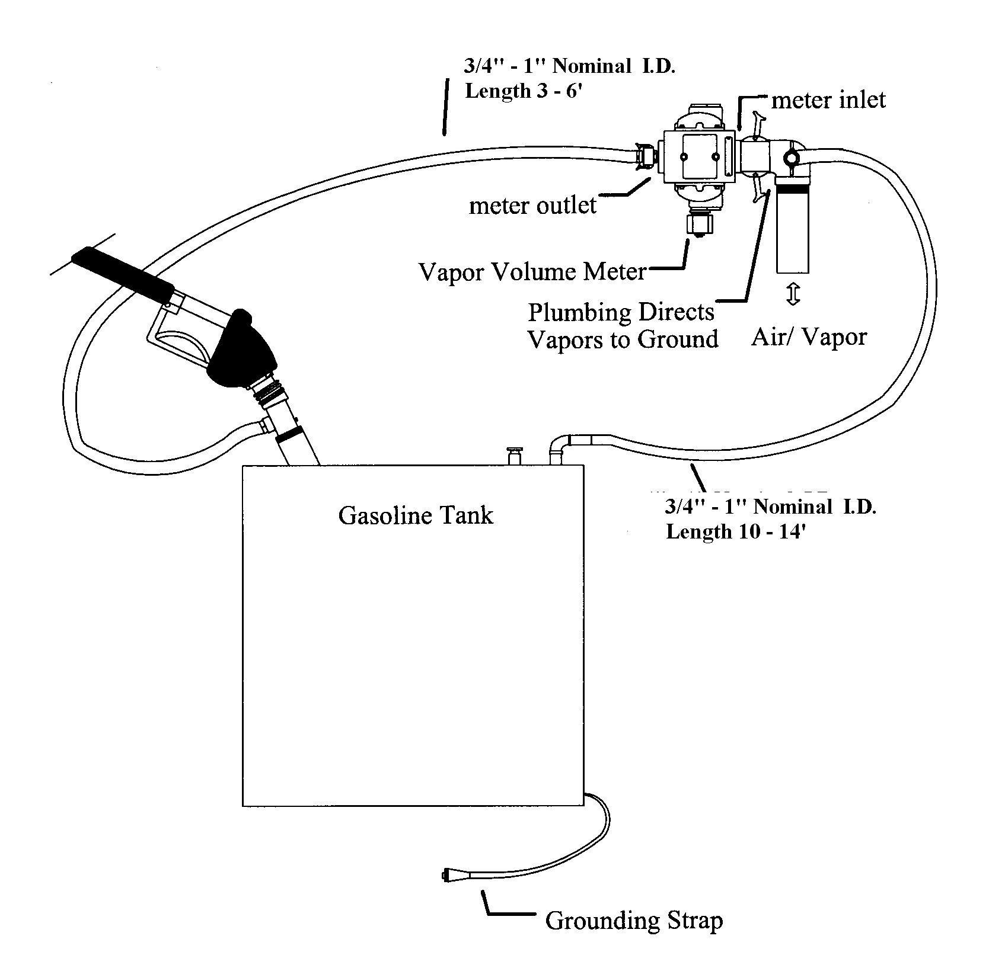
Figure 3
Inlet Elbow 1 ½”
(P/N TVLM-013)

Maintenance and Care

Although the unit is sturdily constructed, care should be taken in handling and storage. The unit should be kept clean, dry and free of any oils or grease.

Check that the inlet port screen on the volume meter is in place and in clean condition.

Examine the nozzle adapter hose for nicks or tears, replace as necessary.

Battery life: The battery is housed within the unit itself and cannot be removed. The battery is rechargeable and the unit comes with a 120 volt ac and 12 volt dc chargers. If the unit is left on for many hours, the 12 volt auto charger must be used to restore the battery as the 120 volt charger will not work when the voltage is below 7 volts.

Calibration: For use in California and in accordance with ARB’s Exhibit 5, the TriTester must be calibrated every 180 days. After the expiration date has arrived, the display will read "CALIBRATION EXPIRED." Calibration is done at Triangle’s facilities in Burbank, California. During the calibration process the unit is checked for accuracy, the battery is renewed and cables are replaced as necessary. The complete unit with all components must be returned for calibration.

The Vapor Flow Meter and the Electronic Unit is a calibrated pair and cannot be mismatched with other units. Disassembly of the unit is not possible without breaking the seals and voiding warranty.

TriTester Replacement Parts

Description Part Number

Complete System TVLM-001
Electronic Processor Unit TVLM-002
Vapor Flow Meter TVLM-003
120 volt charger TVLM-004
Auto charger TVLM-005
Inlet Port Screen TVLM-006
Squeeze Bulb TVLM-007
Squeeze Bulb Slip Adapter TVLM-008
Spout Ring TVLM-009
Surrogate Spout TVLM-010S
Carrying Case TVLM-011
Spout Adapter TVLM-012
Elbow Inlet Adaptor TVLM-013

Technical Support

Triangle can be reached at: Mailing Address
Phone (800) 767-6004 Triangle Manufacturing, Inc.
Fax (818) 301-7777 3726 Park Place
Web http//www.trienv.com Montrose, CA 91020

Warranty

All Triangle parts and products are thoroughly inspected and tested at our factory from receipt of raw materials to completion of final assembly. Triangle Environmental, Inc. (TEI) will, at its option, repair, replace or credit the purchase price of any TEI manufactured product which proves upon examination by TEI to be defective in material and/or workmanship within TWELVE (12) MONTHS from the date of purchase if the original purchaser returns the warranty registration form provided herein. Buyer must return all warranty items to TEI, transportation charges prepaid.

This Warranty does not apply to equipment which has been damaged by misuse, including liquid damage, improper operation or maintenance or which is altered or repaired in any way or for which the factory seals have been broken.

The Warranty provisions contained herein apply ONLY to original purchasers who use the equipment for commercial or industrial purposes.

There are no other warranties of MERCHANTABILITY, FITNESS FOR A PARTICULAR PURPOSE, OR OTHERWISE, and any other such warranties are hereby specifically disclaimed.

TEI assumes NO LIABILITY for labor charges or other costs incurred by Buyer incidental to the service, adjustment, repair, return, removal or replacement of products. TEI ASSUMES NO LIABILITY FOR ANY INCIDENTAL, CONSEQUENTIAL, OR OTHER DAMAGES UNDER ANY WARRANTY, EXPRESS OR IMPLIED, AND ALL SUCH LIABILITY IS HEREBY EXPRESSLY EXCLUDED.

TEI reserves the right to change or improve the design of any TEI equipment without assuming any obligations to modify any equipment previously manufactured.
WARRANTY REGISTRATION

Thank you for purchasing TriTester, the latest in Phase II assisted vapor recovery testing. We want your unit to be free from defects in material and workmanship, so take a moment to read the warranty, fill out this form and fax or mail to Triangle Environmental, Inc. at:

Triangle Manufacturing, Inc.
3726 park Place
Montrose, CA 91020
ATTN: Warranty Registration

Phone (800) 767-6004
Fax (818) 301-7777

Please print

Name of Company_______________________________________

Street Address__________________________________________

City, State & Zip________________________________________

Phone Number__________________________________________

TriTester Serial #_______________________________________

TriTester Part #_________________________________________

TriTester Version #______________________________________

